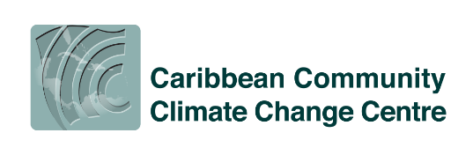

Media Contact: Ms Tecla Fontenard FOR IMMEDIATE RELEASE
Tel: (501) 822-1104
Email: pr@caribbeanclimate.bz

MEDIA RELEASE
November 25, 2023

(City of Belmopan, Belize) Statement from Dr Colin Young, Executive Director of the CCCCC on International Day for the Elimination of Gender-Based Violence Against Women

The 16 days of activism against Gender-Based Violence provide an opportunity for a revitalization of commitments to end violence against women and girls and those most vulnerable in our society. At the CCCCC, we are proud to join the global advocacy campaign to ensure that women and girls are protected from harm in the work that we do and internally within our Organization.

Climate-induced disasters often result in increased cases of gender-based violence. Disasters create drivers that fuel gender-based violence by disrupting protective systems, inducing traumatic and psychosocial stress, increasing inequality and financial dependence, and increasing the need for basic necessities, amenities, and access to adequate healthcare. At the CCCCC, we collectively work to ensure that the Caribbean becomes more resilient to the adverse effects of climate change; we must also remain strongly mindful and committed to ensuring that our projects and efforts do not reinforce destructive attitudes and practices that harm women and girls. Instead, our investments in the region should, at all times, empower women and girls as part of our climate resilience building.

In June 2023, the CCCCC Sexual Exploitation, Abuse, and Harassment (SEAH) Policy was approved by the Board of Governors. We have a zero-tolerance approach to any form of sexual violence and other types of gender-based violence. The SEAH policy applies to all staff, consultants, service providers, and third parties with whom the CCCCC does business. It is paramount that we hold ourselves and our partners to the same standard to ensure that we protect staff, our beneficiaries, and stakeholders from any form of sexual and gender-based violence.

On this International Day for the Elimination of Gender-Based Violence Against Women and Girls, I take this opportunity to echo the global call to Invest to Prevent Violence Against Women and girls. Over the next 16 days, in particular, and throughout the year, let us individually and collectively acquaint ourselves with our SEAH Policy so that we can internalize and live by its ideals.

Investing to prevent violence against women and girls is a collective responsibility.

Please join me in working every day to ensure that the CCCCC and our partners foster an environment free of sexual violence and any type of gender-based violence. I know I can count on your support and commitment.

-END-

________________________________________________________________________
The Caribbean Community Climate Change Centre is an inter-governmental Caribbean Community (CARICOM) institution that is mandated by the CARICOM Heads of Government to coordinate the Region’s response to climate change. We maintain the Caribbean’s most extensive repository of information and data on climate change specific to the region, which in part enables us to provide climate change-related policy advice and guidelines to CARICOM Member States. In this role, the Centre is recognized by the United Nations Framework Convention on Climate Change, the United Nations Environment Programme, and other international agencies as the focal point for climate change issues in the Caribbean. The Centre is also one of the few institutions recognized as a Centre of Excellence by United Nations Institute for Training and Research. CCCCC is empowering the Caribbean Community to act on climate change.

-END-

